Proposal Outline: Gangari Mobile Security Awareness System

Terence Coard
ENTD 313

Prof. Peter Bonk
American Military University
February 22, 2017

Proposal Outline: Gangari Mobile Security Awareness System
Executive Summary
The development of ‘Gangari Mobile Security Awareness System’ is an essential tool in the society for sharing information in the society. Running on mobile devices, the App outreach is possible to billions of users across the world. With features for sharing diverse information, the App possesses a competitive standard to others such as Facebook and Twitter which run as social medias. The App only exists to exchange information across various fields that affect human life.
Application Framework
Gangari Mobile Security Awareness System App is a solution to massive data collection problem on reports of diverse population opinions through the web. The App will use Crowd Sourcing Systems running on an Android platform for the Front-End use, and a Google App Engine as the Back-End.
The user can upload details of an incident which can be viewed by a different user using the same application. The App offers a platform for information sharing and dissemination to reach a large number of users.
Visual Design Tool Showing App
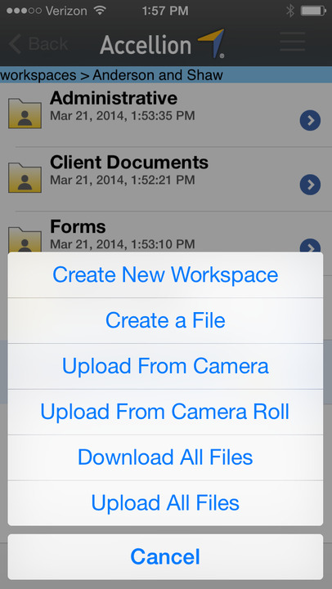
Figure 1: Gangari Security Mobile App
Providing the space for the creation of various data – “New Workspace, File Upload, Camera Upload, Camera Roll, Download All Files, and Upload All Files,” is a pathway for the relaying more information on various issues. The various features give various options for the kind of information to be uploaded or downloaded through the App.
Mobile Design Elements
The design elements include Crowd Computing Services, Computer infrastructures for coding of the App, Antivirus for Security and Firewall, Mobile Gadgets to many users across the world, and Internet availability.
Testing Strategy
The testing strategy should be implemented in phases. Various regions with access to mobile devices and the internet should come first to test the efficiency of the App's performance. A test of the time of upload of information and its dissemination over the network to other users is important to analyze the success of the App.
Marketing Strategy
The marketing strategy focuses on various sectors including sports, music industry or entertainment, media reporting, education, and police departments for crime reporting. The divergent of the target audience will facilitate how news reaches various destinations and how they spread.
Future Adaptations
The future adaptations of the App should enhance coverage of various sectors across the world. These should include health, media, entertainment, sports, business, governance, law enforcement, and nutrition. The App should serve the society effectively by disseminating information.

